Raising accessibility standards for new homes
The government is consulting now on options to raise accessibility standards for new homes in England. (There are different rules in the rest of the UK).
This document is designed to help organisations and individuals submit feedback to this consultation. The deadline for feedback is 11.45pm on 1 December 2020.
You can use these links to navigate this document:
- Suggested responses
(You can copy and paste these as a starting point should you wish)
- Supportive information
(You can use any of this information as you wish)

Tell the government we need more accessible homes now
The Housing Made for Everyone (HoME) coalition is calling for immediate action to tackle the UK’s acute and growing shortage of accessible homes. We want the government to act urgently to raise standards to ensure all new homes, across all tenures, are built to be accessible and adaptable.
The HoME Coalition was founded by the Centre for Ageing Better, Habinteg, Age UK, RIBA, Care & Repair England, Disability Rights UK, Housing LIN, the National Housing Federation, the Chartered Institute of Housing and the Town and Country Planning Association.
Please help us tell the government that change is needed to build the right homes for the future by responding to this consultation now.

Responding to the consultation is vital because:
- The need for accessible homes is urgent and growing larger all the time. Currently, 91% of homes do not provide the four access features for even the lowest level of accessibility. We estimate that some 400,000 wheelchair users are living in homes that are neither adapted nor accessible.
- The social and public savings benefits are enormous
Accessible and inclusive homes can help to improve our independence at home, keep us safer, and delay or avoid unwanted moves to more specialist housing - all of which can help lower costs for social care and NHS care.
At the same time having an accessible home can improve wellbeing, foster social and family relationships and reduce isolation and loneliness. Building homes that are future-proofed, not just built for the first owners will help make housing more sustainable and reduce the environmental impact.
- It’s a low-cost investment in future-proof design.
Building to accessible and adaptable standards does not cost the earth. Additional costs over that of a three-bedroom semi-detached home built to the current baseline standard is £521 with a further space cost of £866. This is a very small percentage of the price of a home on the market. Crucially, were all homes built to the same higher standard this would level the playing field and lower the average additional cost to developers.

Supportive background information
This section offers background information for those who would like it for the question responses. The next section offers our suggested responses based on this information, should you wish to use those as your starting point.

Accessible housing
Accessible housing means homes and neighbourhoods that are designed and built for everyone but are especially beneficial to older and disabled people. The aim is to create a safe, comfortable, barrier-free living environment for as wide a range of people as possible.
Accessible homes can be houses, flats, maisonettes or bungalows; homes that help us live well, make life easier and safer, and support independence. They can be designed to provide different levels of accessibility to suit different levels of need, and will include features that are useful or necessary from the start, (such as wider halls and doors), and others that we don’t need now but may need later (such as a hidden floor gulley that allows us to replace the bath with a walk-in shower). The vast majority of accessible housing looks and feels like ordinary housing - inside and out.
Specific building regulations (Part M) set standards for the design and construction of buildings to ensure people can access and move around inside buildings. The consultation looks at options for making changes to these regulations. But it also asks whether the government needs to act now or whether it should spend more time considering this issue.

The current system
We have set out below some background information on the different options. We believe that two of the options will result in an increase of accessible homes and you may wish to tick more than one option in order to reflect this.
The current set of regulations that set standards for the design and construction of buildings to ensure people can access and move around inside buildings are referred to as Part M of the Building regulations. They set out 3 levels:
- M4(1) – Visitable dwellings: This is the lowest level and the current baseline standard for building new homes. The basic criteria for a home to be ‘visitable’ are level access to the main entrance, a flush threshold, sufficiently wide doorways and circulation space, and a toilet at entrance level. Category 1 is more lenient on allowing exceptions – these are only “avoided where possible” - meaning that homes often don’t end up with step-free access or amenities that can be easily used. This standard also does not future-proof homes, as they aren’t built to be easily adaptable.
- M4(2) – Accessible and adaptable dwellings: This category is also described as ‘age-friendly’ or ‘lifetime’ housing. These standards are slightly stricter than Category 1 and ensure no steps between the pavement and the main entrance, more space to move around in all areas of the home, and that features are easily adaptable to improve accessibility and functionality in the future as needed.
For example: the walls are strong enough to install grab rails if required, there’s a hidden floor gulley to allow a walk-in shower or wet room to be easily installed, the staircase is wide enough to allow a stairlift - simple things built into the structure and space of the home that allow a person to remain independent for longer. These standards make home comfortable for the millions of us who find it hard to move around our homes or use a wheelchair for part of the time.
- M4(3) – Wheelchair user housing: This is the only category intended to provide a home suitable for those of us who use a wheelchair all of the time.

How the current system works/doesn’t work:
M4(1) is currently the only one that is mandatory, and it sets a very low bar.
At the moment, local authorities set out plans for which standard of new homes will be built in their area. They can set out their expectations to developers of how many M4(2) and M4(3) houses are needed if they can show that there is enough demand from older or disabled people living in the area to warrant building these homes.
Developers can argue that accessible housing is more expensive (and therefore less profitable) and negotiate that houses are built to the lowest allowable standards. Given the resource challenges that local authorities currently face we are concerned that their capacity to research and evidence need in a local policy and the imperative to build more housing quickly is making it difficult to ensure enough accessible homes are built.
Having M4(2) as the baseline standard would remove this issue by levelling the playing field for all developers as well as simplifying planning and building processes. It would also free up resource in local authorities to focus on ensuring enough wheelchair accessible homes are being built.

How to respond:
Below is some suggested text to support your response to the consultation.
The government is seeking views via an online survey.
Alternatively, you can send an email or a written response answering the questions. After being asked to share some information about you/your organisation you will be asked the following questions:
Question 12: Do you support the government’s intention to raise accessibility standards of new homes?
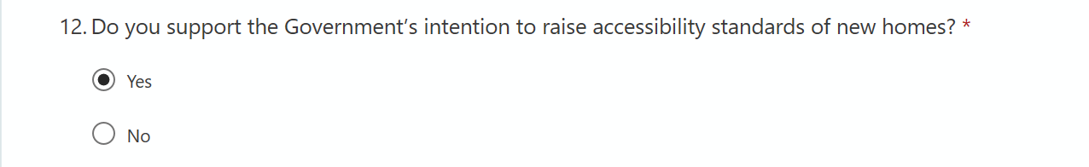
Suggested response: Yes
Question 13: Please explain your reasons.
Suggested response:
The government is right to seek to raise accessibility standards and should do so as soon as possible by making changes to the building regulations now. To achieve this, the government’s approach must include making the accessible, adaptable design standard (M4(2)) the mandatory baseline for all new homes as the starting point.
The reality is that millions of us, particularly those who are older or disabled, live in homes that don’t meet our daily needs. England’s existing housing is simply not suitable for the diverse and changing needs of our ageing population, and often the new homes we build aren’t either.
The UK has the oldest housing stock in Europe. Figures released in the English Housing Survey (EHS) this year showing that an overwhelming 91% of homes do not provide the four main features for even the lowest level of accessibility – a home that is ‘visitable’. We estimate that some 400,000 wheelchair users are currently living in homes that are neither adapted nor accessible/visitable.
In the next twenty years, there will be a huge age shift in our society with one in four of us aged over 65. One in five adults aged 65-69 need help with one or more activities of daily living (such as bathing, cooking or using the toilet). By the time people reach their 80s, this figure rises to more than one in two of us. But as it stands, only one new accessible home is planned for every fifteen people over 65 by 2030. Contrary to common misconceptions, more than 90% of older people live in mainstream housing rather than specialist housing or care homes. Understandably, most of us want to stay in our own homes, streets and communities for as long as we can, and our homes should enable more of us to do this.
We must build new homes that meet the current acute need and the growing future need in mind.
Question 14: Which of the 5 options do you support? You can choose more than one option or none.
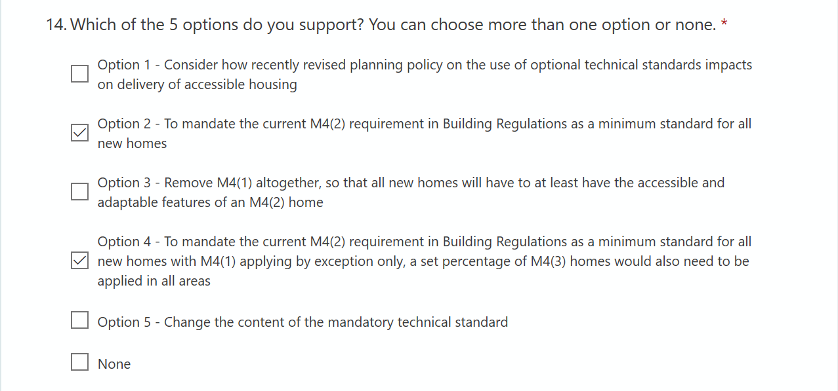
Suggested response:
Tick Option 2 as a minimum. You might also choose to tick Option 4.
Question 15: Please explain your reasons, including the advantages and disadvantages of your preferred option(s).
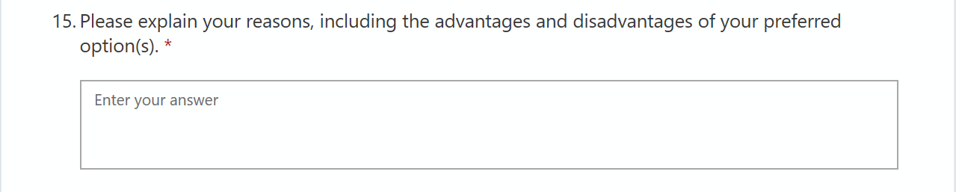
Suggested response:
Option 1: The HoME coalition strongly object to this option.
It is vital that we do something to increase the number of accessible homes – Option 1 is effectively to ‘do nothing’. This is not acceptable and will have a negative impact on the lives of disabled people or older people now and in the future.
We have a dire shortage of accessible and adaptable new homes and to continue to do nothing to address that would be a disaster for our growing population of older and disabled people. We must act now. If Option 1 is chosen, it will result in more damaging delay.
Option 2: The HoME coalition strongly supports Option 2
The Housing Made for Everyone (HoME) Coalition has campaigned for a higher regulatory baseline for accessibility of all new homes (M42), and, where need can be demonstrated for M4 Category 3 (wheelchair user), the government should lower the current high bar needed to introduce relevant planning policies. We are therefore strongly supportive of Option 2 of the government's consultation response which proposes to make M4(2) the minimum baseline.
By making M4(2) mandatory, we believe that this will help to free up local authority capacity by removing the need to make the case locally. This will help local authority planning departments and Building Control and/or Access Team to gather evidence and set robust policies for an appropriate level of M4(3) housing for their areas. Many developers themselves are in favour of this change and consider that it will not lead to fewer homes being built.
In order for sufficient wheelchair accessible (M4(3)) homes to be delivered at a local level, the HoME coalition want to see additional steps being taken by national government. For example:
- We would like to see government set a clear expectation that each local planning authority will set out a plan for a number of wheelchair accessible properties to be built within each iteration of their local plan. (This would prevent local plans being approved that have no provision for wheelchair accessible properties at all and in doing so will help local plans deliver their Public Sector Equality Duty).
- We would like government to set a firm expectation that all local authorities maintain a register of the number of people awaiting wheelchair accessible housing in their area along with details of their household profile and tenure type that will help to plan the right homes to meet needs across the country.
Option 3: The HoME coalition advises against this option
Option 3 proposes to get rid of M4(1) altogether and only allow homes to be built to M4(2) or M4(3). This will have similar consequences to Option 2 but removes the ability for any home to be built to the previous M4(1) standard. Whilst this should result in more accessible homes being built, the requirement for homes to have a no-step entrance in order to meet M4(2) would prevent some much needed homes from being created at all and could therefore reduce delivery of new homes (which in turn could have a negative impact on development longer term). For a small number of exceptional properties, such as those above a shop for example, we believe there is a case for allowing a M4(1) to still apply. However, this must be seen as exceptional and extremely rare with strict tests that developers will have to meet to prove that M4(2) is not possible. The default position must be that every home is required to meet M4(2) as a minimum.
Option 4: The HoME coalition is supportive of Option 4 if additional steps are taken to support its success.
Option 4 also delivers on the priority aim for the HoME Coalition of mandating M4(2) homes as the new baseline, with M4(1) applying only in exceptional circumstances where M4(2) cannot be achieved, and setting a nationally applicable percentage of new homes to M4(3) wheelchair user standard.
The HoME Coalition can see the benefits of taking such an approach, so long as further steps are also taken, including:
- allowing flexibility for local planning authorities, should some areas wish to go above a national minimum percentage for wheelchair accessible homes.
- national and local government support the development of a national accessible housing register so that it is much easier for wheelchair users to find and apply for suitable housing in which ever location and tenure they require.
Option 5: The HoME coalition object to this option.
Option 5 proposes to open up a review of the requirements under M4(1) and M4(2) with the aim of the minimum requirement a bit stronger but not as strong as M4(2).
We believe that M4(2) as it is currently worded captures what should be minimum standard for new homes.
Opening up a separate review into the detailed wording of the different levels in Part M of the building regulations is a distraction and will delay the vital strengthening of building standards that needs to happen right now.
Question 17: Do you agree with the estimated additional cost per dwelling of meeting M4(2), compared to current industry standards, in paragraph 44?
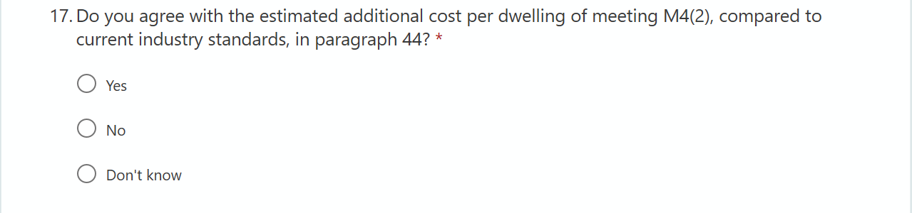
Suggested response: No.
Question 18: If no, please comment on what you estimate these costs to be and how you would expect these costs to vary between types of housing e.g. detached, semi-detached or flats? Please provide any evidence to support your answers.
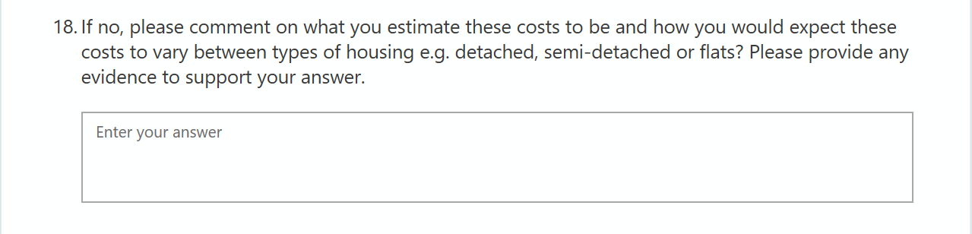
Suggested response:
The £1400 figure at paragraph 44 is a sensible average estimate for a particular type of development but given the huge range of properties and the places they are built, it is very difficult to come up with a meaningful average cost for introducing higher accessibility standards across the board.
There may be a difference between the build cost and space required for a small block of Category 1 flats and a similar block of Category 2 flats where the installation of a lift is needed to make it accessible. However, given that a flight of steps represents an insurmountable barrier for most wheelchair users and many older people, providing lift access is the right thing to do. In most cases much of the extra cost required can be significantly reduced by redesigning the dwelling and the layout of the development.
Crucially, if Category 2 becomes the new minimum standard in the Building Regulations, all developers will be factoring in the same extra costs and will be buying land with the same assumptions. Land values will reflect those assumptions and the impact on individual developers currently trying to build to Category 2 without a level playing field will be reduced.
We disagree that raising the mandatory standard will necessarily create significant costs that will fall on developers. If higher accessibility standards are mandatory and processes standardised, for the most part the impact of additional building and space costs can be relatively low.

Question 19: Do you agree with the proportion of new dwellings already meeting or exceeding M4(2) over the next ten years in paragraph 44?
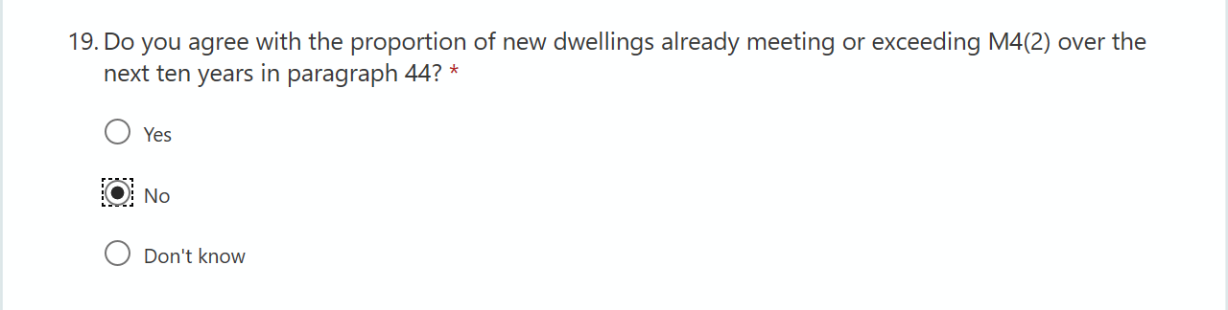
Suggested response: No

Question 20: If no, please comment on your alternative view and how you would expect this to vary between types of housing e.g. detached, semi-detached or flats? Please provide any evidence to support your answers.

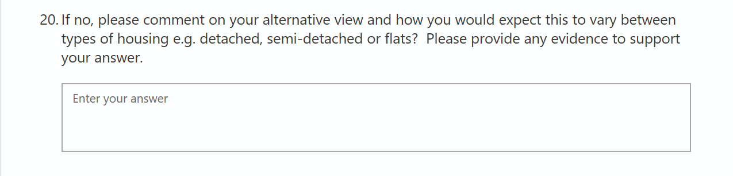
Suggested response:
Over the past decade, the English Housing Survey shows we have only managed to increase the number of households with at least one adaptation for a person with a disability by 1%, from 9% to 10%. Only 9% of homes in England have all four accessibility features.
The proportion of wheelchair users that live in accessible and adapted homes has remained similar across the decade. 57% of wheelchair users live in an adapted home and only 16% live in an accessible home.
In the next twenty years, there will be a huge age shift in our society with one in four of us aged over 65. One in five adults aged 65-69 need help with one or more activities of daily living (such as bathing, cooking or using the toilet). By the time people reach their 80s, this figure rises to more than one in two of us. But as it stands, only one new accessible home is planned for every fifteen people over 65 by 2030.
A survey carried out by the Centre of Ageing Better of local authority housing and planning officers found that 97% of local authorities say their need for accessible homes will increase in the next 10 years, with a quarter of local authorities surveyed describing their need for accessible homes as severe. Nearly 90% of local authorities who completed the survey support our campaigning for changes to accessibility standards in building regulations.

It is not clear what the evidence base is for the figures provided in the consultation document. What is clear is that the existing number of accessible homes is woefully inadequate for current needs, and that demand for accessible and adaptable homes will only increase given demographic trends. Even if the government’s suggestion that the proportion of new homes built to Category 2 will to increase to 30% without changes to regulation were accurate – this would still mean the majority of new homes built will be unsuitable for the obvious needs of our population. We would effectively be building in more costs in adaptations needed in the future, more cost in terms of NHS and care spending and more carbon costs as homes aren’t fit for purpose in the long term.

Question 21: Do you have any comments on the costs and benefits of the other options set out in the consultation document?
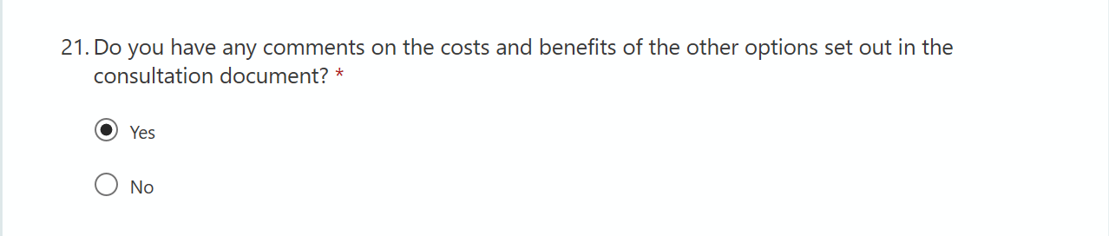

Suggested response: Yes

Question 22: If yes, please provide your comments including any evidence to support your response.

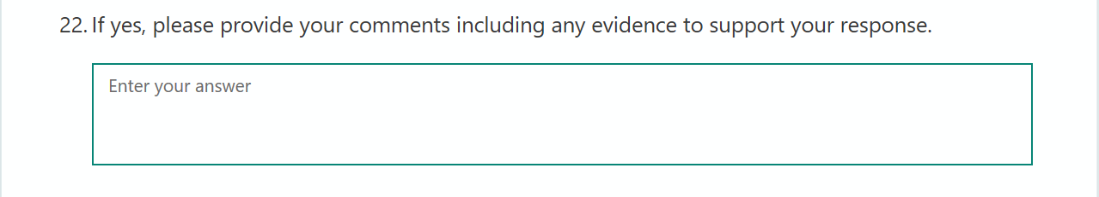

Suggested response:
The positive social impact of building more accessible homes has the potential to be vast. We would expect this to reduce demand for NHS and social care services and costly adaptations made to homes in order to meet immediate needs. If houses are not built to be accessible from the offset, then these costs are simply pushed into the future and on to individuals, the government and the taxpayer. It is much more effective to build the type of homes we need now than to adapt unsuitable properties in future, often at huge costs.
For comparison – the cost of delaying building the homes we need based on the figures currently available:
- A report commissioned by the government estimated that on average a three-bedroom semi-detached house would cost an extra £521 to build to the higher M4(2) standard, with a further space cost of £866 – an overall total of £1,387 per dwelling.
- An average Disabled Facilities Grant to adapt a M4(1) home = £7,000 (one-off payment)
- Residential care costs if your home becomes unsuitable = £29,000 per year
For the foreseeable future, retrofitting and adapting existing homes will be necessary for many people as 91% of existing homes do not meet even the lowest threshold of visitability. However, it can be expensive to retrofit and, in some instances, not practical because of the design of the home. Future proofing the homes we build now means that less adaptations will be required, and those that are can be achieved more effectively and at lower cost. This is a crucial part of the solution.

Making all new homes accessible and adaptable will mean that more people will be able to stay in their own homes as their needs change, rather than being forced to move prematurely and unnecessarily into supported or specialist housing which cost much more. Returning home from hospital will be smoother and faster, the likelihood of falls and other housing related health problems will be less frequent, and people’s need for care at home will reduce, all of which will free up much needed NHS and social care resource.

Question 23: Do you have any comments on the initial equality impact assessment?

Suggested response: Yes

Question 24: If yes please provide your comments including any evidence to further determine the positive and any negative impacts.

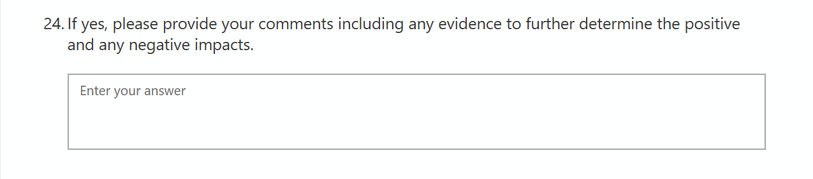

Suggested response:

The Equality Impact Assessment provides no evidence of comparative benefits of different Options. We would encourage the government to carry out more work to explore the evidence base for the impacts of different options.

Options 2 and 4 which would raise the minimum mandatory accessibility standard to M4(2) will have the biggest impact of increasing the number of homes where older and disabled people can live safely and independently. These options have clear positive impacts that the other options will not achieve.

Thank you for submitting a consultation response!
Your response is important – thanks for making your voice heard and telling the government that change is needed to build the right homes for the future. Building accessible and adaptable new homes will help make a difference to millions of lives, now and in the future.
For updates on the HoME campaign and consultation please contact us at HoMEinfo@ageing-better.org.uk

References

Southampton City Council and the Housing Learning & Improvement Network (2019), Identifying the health care system benefits of housing with care. Available at: https://www.housinglin.org.uk/_assets/Resources/Housing/Support_materials/Reports/HLIN_SouthamptonCC_HwC-Health-Care-System-Benefits_Report.pdf
Nicol S, Roys M, Ormandy D and Ezratty V (2016) The cost of poor housing in the European Union BRE. Available online at: https://www.bre.co.uk/filelibrary/Briefing%20papers/92993_BRE_Poor-Housing_in_-Europe.pdf
Ageing Better calculations based on ONS (2019), ‘Population projections’ & Habinteg (2019), ‘A forecast for accessible homes’. Available at: https://www.habinteg.org.uk/download.cfm?doc=docm93jijm4n2151.pdf&ver=2575
Based on care home data and estimates of the number of older people who live in specialist housing. Office for National Statistics (2014), ‘2001 to 2011 Census: England and Wales’. Available at: https://www.ons.gov.uk/peoplepopulationandcommunity/birthsdeathsandmarriages/ageing/articles/changesintheolderresidentcarehome populationbetween2001and2011/2014-08-01
Lloyd, J. (2015), ‘Older Owners Research on the lives, aspirations and housing outcomes of older homeowners in the UK’, London: Strategic Society Centre. Available at: http://strategicsociety.org.uk/wp-content/uploads/2015/10/Older-Owners.pdf
Ageing Better calculations based on ONS (2019), ‘Population projections’ & Habinteg (2019), ‘A forecast for accessible homes’. Available at: https://www.habinteg.org.uk/download.cfm?doc=docm93jijm4n2151.pdf&ver=2575
Foundations (2015), ‘Linking Disabled Facilities Grants to Social Care Data: A freedom of information survey’. Available at: https://www.foundations.uk.com/media/4210/foundations-dfg-foi-report-nov-2015.pdf

